Q1).Create an UI which displays Hello your name in one component and returns the output into another component .

(Topics covered in this questions are-components, component injection).

Q2).Create a logo for the project management system in the following manner.

(Topics covered in this question are-components, component injection, Embedding Html and CSS in component).

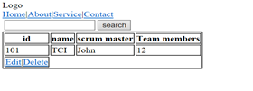

Q3).Create a React demo to display employee details as EmpId, EmpName, and EmpCompany.Here EmpCompany should be accepted as default value and should get print by default and also need to validate EmpId.

(Topics covered in this question are-components, props, Default Props, Prop Types).

Q4).Create a React demo to create an array of numbers and listing all even and odd numbers from the list.

(Topics covered in this question are-components, props, map function).

Q5).Create an array of objects with CustomerID, CustomerName, and CustomerAddress.Extract Customer names starting with ’A’ and Customer address with India.

(Topics covered in this question are-components, filter method).